1)

a. (a (b | a)\* b ) | (b (b | a)\* a)

b. (baa (a|b)\*)

c. (a ((b\*) a)\*) | (b (a (b\*))\*)

2)   
  
(1|2|3|4|5|6|7|8|9)\* (0|1|2|3|4|5|6|7|8|9)\* (0|5)

3)

НСА

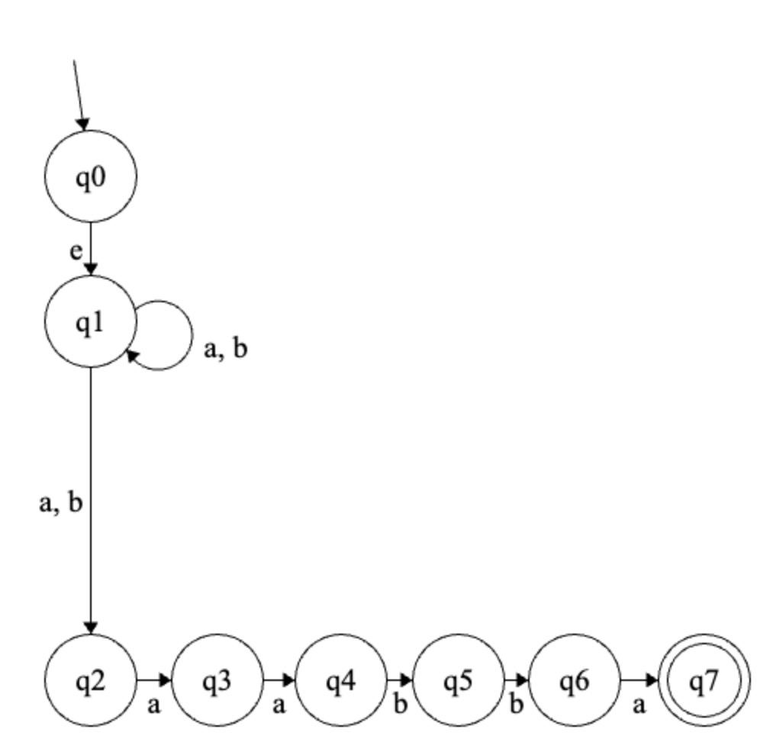

ДСА

